I GIVE MY PLEDGE AS AN AMERICAN, TO SAVE AND FAITHFULLY DEFEND FROM WASTE, THE NATURAL RESOURCES OF MY COUNTRY; ITS AIR, SOILS AND MINERALS, ITS FORESTS, WATERS AND WILDLIFE. I WILL HELP EDUCATE FUTURE GENERATIONS TO BE RESPONSIBLE CARETAKERS OF THE RESOURCES OF AMERICA

FEBRUARY 2015

Volume 70 No. 2

Club Website- <http://rrgclub.tripod.com/clubhome>

Club Facebook Site – [www.Facebook.com/RichlandrodandGunClub](http://www.Facebook.com/RichlandrodandGunClub)

Northwest Game Recipes Web Site – [www.northwestgamerecipes.com](http://www.northwestgamerecipes.com)

2014-15 Officers

Kirby Hammond, Pres. 396-7723 Matt Lucas, Vice Pres. 845-1207

Richard Libby, Treas. 947-0498 Frank Scopa, Sec. 375-4748

**MEETINGS AND DEADLINES**

FEB. GENERAL MEETING—7 pm, Tuesday Feb 2, Richland Public Library, 955 Northgate Drive, Richland

BOARD MEETING—7 pm, Tuesday, Feb 17, Hunter Education Facility at Griggs in Pasco

NEWSLETTER DEADLINE—Jan.18, Call Frank Scopa at 375-4748 or secretary.rrgc@yahoo.com

**FEBRUARY MEETING:** Matt Lucas/Kirby Hammond

The speaker will be Dave Hedden of Hedden’s Northwest Sport Fishing. His topic will be winter sturgeon fishing. His talk will discuss cold water presentations and the differences between winter and summer fishing.

**FEBRUARY MEEING:**  Kirby Hammond

A copy of the RRGC revised Bylaws will be attached to the newsletter as well as the revised Quality Trip Rules. There will be a general election in March to approve the revisions. Approval of the Bylaws is the first step to obtain our Non-Profit status with the IRA as a 501(c)(3) corporation. The General Membership will be required to vote at the March General Meeting. There is a 30 day review requirement prior to the vote on the Bylaws. A Nominating Committee has also been established to propose candidates for Club leadership positions. All of the leadership positions must be voted on in March for one year terms as well as those of Directors and Special Volunteers. The Nominating Committee is comprised of Mike Estes, Dave Myers and Matt Cummings. They will be contacting members in order to determine interest or recommendations. Mr. Hammond announced at the Board Meeting that Helen Newman has volunteered to take over the primary duties of the updating the RRGC Face Book page. Additionally, Sam Morrison has volunteered to assist Russ Wyer in maintaining the RRGC webpage as well as performing IT support for the Club. Both volunteers have taken some of the load off of the Secretary’s duties.

**JANUARY MEETING RECAP:** Frank Scopa

Our January speaker was Tom Moore, a local fishing guide and tournament fisherman. He has been fishing the local region for numerous years and additionally works in the Griggs Sporting Goods Section in Pasco. His presentation could be summed up that for winter walleye fishing, slow and deep presentations work the best. He recommends talking with the local sporting goods stores for local information as well as other fishermen who have been out recently. A general statement of his talk would be if jigging, to keep the lure approx. one foot off of the bottom for the rise and fall of the lure. If using a lure, keep the lure approx. 3 feet off of the bottom when fishing upstream. His recommendation is to use a worm and worm harness for fishing downstream. He noted that at the present time, Washington State does not have a limit on walleye. There is a better chance of catching a trophy in the winter than in the summer. His last bit of advice is as follows for the 4 phases of a walleye fisherman; 1. Just catch a walleye. 2. Just catch my limit of walleye. 3. Just want to catch a trophy. 4. Did we have a great day?

**BULLETIN HELP:** Frank Scopa

If you are receiving this bulletin via U.S. Mail and you have an email account, please send an e-mail to Frank Scopa at [secretary.rrgc@yahoo.com](mailto:secretary.rrgc@yahoo.com) with your email address. Printing and mailing costs are eating into the club’s ability to carry on our stated goals (see pledge above). Your help is greatly appreciated. There are now just three e-mail addresses on our roster that have issues that result in undelivered electronic newsletters. I will continue to send out requests for correction this next month. We should be current as to mailing addresses for the hard copies.

**NEW MEMBERS AND MEMBERSHIP:** Jen Gardner, two new members were voted on and accepted by the Board. The new members are; John Propson of Richland and Dave Gerdes of Kennewick. Please provide a warm welcome to them when you meet them at the next meeting. All members are reminded that their 2016 dues must be current in order to purchase Quality Trip Tickets. This can be done at the Big Game Dinner but early renewal reduces confusion. An effort is being made to ensure that all of the end of membership dates are correct and current in the master list.

**TREASURER’S REPORT:** Richard Libby, reported that for calendar year 2014, RRGC took in more funds than were expended. The Treasurer’s Report was voted on and accepted by the Board of Directors at the Board Meeting held on January 20th.

**NEXT BOARD MEETING:** February 17th, 7:00PM, Griggs Hunters’ Education Room, Pasco. All RR&GC members are invited to attend.

**BIG GAME BANQUET:** Dave Myers

A reminder to all that with hunting season just about over the need for critical entrées for the Banquet still exists. Bring any meat donations to either a general meeting or a board meeting, we will transport them to our storage location. John Prather has generously offered freezer space at his home in Finley. A sign-up sheet will be available at the February club meeting. Included with the cuts of meat diagram, is the information to be provided with all game meat donations. This is a WDFW requirement.

**Standard Meat Cuts**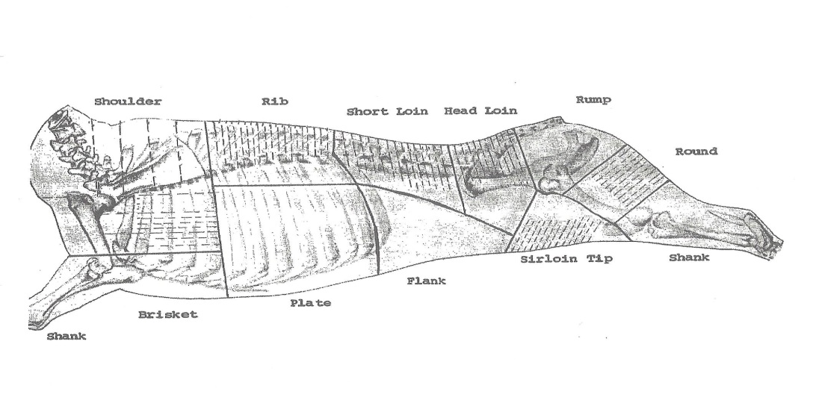

All cuts of big game should be boneless, please no ground meat. Ideally, game birds should also be de-boned. Fish should be provided either frozen in water, or vacuum packed and frozen.

**Information to be provided for all game meat donations indicating permission for the possession of game meat: Name of donor, address of donor, hunting/fishing license number, permit or tag number, the number and kind of animal provided, the date killed, the county and area in which taken and the hunter/fisherman’s signature.**

**GAME RECOVERY:** Chris Mosher/Larry Martin/Dave Myers

There were no recovered deer or elk this past month and no reports of deer or elk hit by vehicles. The Union Gospel Mission is always in need of cash and donations so please keep them in mind.

**IN MEMORIAM OF DAN SEVCIK**

The Richland Rod and Gun Club was recently informed that Dan Sevcik passed away in August of this past year. Dan had been a member of RRGC since 2003. We offer our condolences on his passing to his widow Mrs. Rita Sevcik of Kennewick. Mrs. Sevcik has asked that we inform our membership that she is selling Dan’s Duckworth Boat. The complete description of the boat will be listed as the last item in the newsletter. Our deepest sympathies are extended to his family.

**IN MEMORIAM OF CLARE CRANSTON**

The Richland Rod and Gun Club was informed on January 22nd, that long time member Clare Cranston passed away in his sleep during the night of January 21st. At the present time, no arrangements have been announced. Kirby Hammond did visit with Mrs. Cranston and did extend our condolences.

Dave Myers provided the following comments regarding Clare Cranston’s contributions to RRGC. Clare has been a long-time member of the Richland Rod and Gun Club.  He was the primary instructor in many of the Club sponsored Hunter Education classes.  When I first attended a class he was teaching it was in the basement of Phil’s Sporting Goods on Court Street in Pasco.  He helped the club as Hunter Ed moved from Phil’s to a warehouse in Big Pasco, and from there to its present location at Griggs Department Store.  Clare taught a class about every 6 weeks, and furnished his own firearms when the class collection was insufficient for Range Day.  Until just recently, Clare reloaded most of the rifle and shotgun ammunition used at range day and on the youth pheasant hunts.  As we all know, Clare had an opinion on most things, and he was willing to share that opinion with others.  He was often arguing with the WDFW to do more for the Hunter Ed program and to correct errors that were present in the State’s documentation.  He, Don Board and Don Hartshorn wrote the first manual for Hunter Ed instructors on how to conduct a safe and correct range day.

Clare also loved to fish, his favorite fish seemed to be bluegills and crappies.  He introduced many of us to Thompson Seeps, where he often used a small red-head, white tailed twister (his go to lure) to entice those fish to hit.  He was a catch and release guy, cruising the shoreline of the pond in his johnboat, powered by an electric motor.  As he aged, he was frequently looking for someone to go with him so that he could get the boat in the water.  In recent years, he was a frequenter of Camp Lake where he fished with Dave Piovesan.  When I fished with them,  Clare would take the stern seat and troll with one rod, while casting with another.  He would take as much thrill from catching a small bluegill as he would from a 26-inch largemouth bass.

Clare is probably best remembered for his love of young people and his championing of their outdoor adventures.

Clare and I go back to 1970.  He was a hydrologist with the New Mexico District Office of the US Geological Survey’s Water Resources Division and I was a young hydrogeologist with the Washington District; I replaced Clare on an assignment to an engineering geologist position on Eniwetok Atoll, in the Marshall Islands.  I got to go on all those incidental fishing trips (every Sunday) and he did not.  When we finally met in person shortly after he moved to Pasco; he never let me forget that I aced him out of that incredible experience

**Conservation**

Cistern 1 was rebuilt in January by Larry Martin, Gene Van Liew and Dave Myers. The unit was in such bad shape that it had to be completely rebuilt. With warmer weather coming, repairing the guzzlers will take on a regular schedule. If you are able to volunteer, please contact Larry Martin.

Dale Schielke reports that Annual maintenance activities for the 400 wood duck nest boxes has started and will continue for a couple of months as volunteers are available.  If you are able to help, contact Dale at 375-0183 or [dahlialou@msn.com](mailto:dahlialou@msn.com). Dale installed a camera inside a wood duck box near Twin Bridges, West Richland that has a Western Screech Owl occupying the box, it is possibly considering making a nest. Check for activity in the box at <http://www.ustream.tv/channel/rrgc-nestcam>. This is our new HD camera purchased with a donation from Garden Genies Garden Club.

**SPORTSMEN SHOW**

The Annual Sportsman’s Show held January 16, 17 and 18 at the TRAC Center was a success for RRGC. RRGC provided volunteers for the Lunker Lake, the Pellet Range and the Duck Box build-off. It was estimated that approximately 1,800 hatchery raised trout were furnished for the kids fishing event. Based on the number of kids that came through and fished, it was further estimated that over 1,000 fish were caught. 105 fish carried tags that represented prizes that could be won. 74 fish with tags were caught. There were 31 unclaimed fish with tags. The prizes represented a cash certificates, fishing rods, fishing gear and other related items for children. Donations for the prizes came from Texas Roadhouse, Griggs Sporting Goods, RRGC, Ranch and Home Sporting Goods, Sportsman’s Warehouse, Dairy Queen, and Shuyler Productions. Marilyn Steele was in charge of the Lunker Lake effort during the show and Gene VanLiew led the effort for the assembly and tear down of Lunker Lake. The Wood Duck Box build-off was offered again this year. Four boxes were completed by the kids with Dale Schielke’s assistance. As with previous years, a Pellet Range was offered. The Pellet Range was free for the kids. Don Board led this effort once again. It would be a safe assumption that well over 1,500 kids visited all three of our venues this year. There have been very positive comments posted on Face Book as regarding our effort.

**UPCOMING TOURNAMENTS AND CLUB GATHERINGS,** Richard Sharpe

RRGC will host two tournaments this year that will be open to the public. The first will be the Mighty-Mite tournament. The tentative date is 16 May. There will be an entry fee and prizes will be offered. The second tournament will be a Moonlight Catfish Tournament. The tentative dates are the 19th and 20th of June. The catfish tournament will be a catch and kill tournament since additional fish are not needed for the Kids’ Fishing Pond located at Columbia Park. There will be a fish fry after each tournament but only RRGC members can attend due to Board of Health requirements. It was suggested that the $25 entry fee for each of the tournament be applied towards membership in RRGC. Both of these tournaments are in the initial stages of planning so additional information will be made available with actual dates, times and locations provided as plans are firmed up. Richard is also working on a RRGC gathering at Scootney Reservoir. This is just an idea at this time but is being offered to let the membership be aware of future plans. Dave Myers informed the Board that Dave Piovasin is considering another RRGC outing at Camp Lake. There are no definite dates or plans yet but again this is to let the membership know what may be coming up in the spring and summer.

**QUALITY TRIP RULES**

Attached is a copy of the revised Quality Trip Rules. The Board of Directors as well as the Special Volunteers have reviewed and revised the previous version. Please keep these requirements in mind if you win the Quality Trip at this year’s Big Game Dinner. Thanks to Rick Libby for initiating and following through on this effort.

**WANT ADS**

1993 Duckworth, 20 foot jet boat with recently serviced turbine, 352 c.i.Ford Redline motor with 249 engine hours, oil changed and serviced, freshwater cooling (heat exchanger), engine heater for cabin heat, 9.9 HP Honda four stroke kicker motor with electric start and remote controls, Minn Kota 80 lb thrust trolling motor with 5 foot shaft and remote controls, new Trojan batteries for tolling motor and built-in Minn Kota charger, 4 captain’s chairs with swivels, front seats have air ride suspension, Hummingbird fish finder/depth finder, Standard Horizon VHF radio, antenna and GPS receiver, CB radio, stereo, spotlight/docking lights, 4 Folbe fishing rod holders, set up for 2 downriggers with Scotty mounting plates (downriggers not included), life jackets, dock lines, large fishing net, full canvas and waterproof boat cover, 1995 Duckworth trailer with new wheel bearings and seals, and full tank of gas with Stabil gas saver. Note: only ethanol-free premium gas was used in this boat. The boat is listed on Craigslist for $24,500. Please contact Mrs. Sevcik through the Craigslist add. Thank you.

